 | IQVIATM Work Instruction  Publishing - Producing Clinical and Submission Publishing Deliverables
Document Number and Revision:
CS_WI_RA0292 Revision 4
Document Owner:  Priti Singh | Author(s):  Priti Singh, Parikshith Shanthappa, Amar Tandon

PURPOSE

The purpose of this Work Instruction (WI) is to explain the steps required to produce publishing deliverables. These steps include:
    - Requesting publishing services
    - Import and validation of any prior electronic Common Technical Document (eCTD) sequences
    - Word file formatting, Pre-publishing and post-publishing activities using Adobe Acrobat, ISI Toolbox, and IQVIA Regulatory Publishing Tool (IRPT)
    - Final publishing and electronic submission validation as per the Health Authorities (HAs) standards on their respective web portals
    - Standard Quality Control (QC) process
    - Delivery of published output to the client for review (both internal and external)
    - Using IQVIA RIM Smart for compilation activity and performing submission publishing activities and use of IQVIA eSubmission Validator and Lorenz eValidator for validating the submission
    - Dispatch submission packages/documents to HAs or sponsors
    - Acknowledgement of Electronic Submission Gateway (ESG) and Archival of Final Published/Submission Output

SCOPE

  - This WI applies globally to all publishing projects for which a client contracts IQVIA RADDS Publishing Center of Excellence (CoE) to publish a deliverable. The same principles apply for all Data Management (DM), Medical Writing (MW), and Regulatory Affairs & Drug Development Solutions (RADDS) deliverables that include publishing.

ROLES AND RESPONSIBILITIES

The following roles perform tasks described within these Work Instructions (WI):

Role | Sections
Project Requestor (PR) | 6.1, 6.4, 6.5
eCTD Lead | 6.1, 6.2
Lead Publisher (LP) | 6.2, 6.3, 6.4, 6.5, 6.6
Publishing Line Manager (PLM) | 6.1, 6.4, 6.5

Role | Sections
Publishing File System Administrator (PFSA) | 6.1
Publishing Tool Administrator (PTA) | 6.1
Publishing QC Requestor | 6.2, 6.5
Publishing QC Reviewer | 6.2, 6.5

DEFINITION

Submission Publishing (SP): Preparation of fully compliant electronic or paper deliverables that are ready to be submitted to HA. Examples include, but are not limited to, Investigational New Drug (IND), New Drug Application (NDA), Biological Licensing Application (BLA), Marketing Authorized Application (MAA), New Drug Submission (NDS), Clinical Trial Application (CTA). The work area occurs in the Remote Desktop Sharing (RDS) file share. See Sections 6.1 through 6.3.

Clinical Publishing (CP): Preparation of documents in the Submission ready format, including basic Word Formatting, PDF compliant settings required for HA electronic submission standards. Examples include Protocols, Clinical Study Reports (CSR), Investigator Brochure (IB), Case Report Forms (CRF). The work area occurs in the publishing (“Pub”) file share. See Sections 6.4 through 6.6.

MATERIAL AND EQUIPMENT

Not Applicable

PROCEDURE

  - Submission Publishing - Project Initiation and Set-Up
Source documents to be provided for publishing may include, but are not limited to, content final MS Word, Adobe PDF, MS Excel, and MS PowerPoint files. MS Excel and PowerPoint files must be ready to be converted to PDF and should not require additional manipulation. The PR for submission publishing can be “IQVIA notifier to RADDS publishing CoE that a new project has been awarded.” This is typically the Project Leader or Regulatory Lead for projects that include a RADDS component, or the client if the external client is involved in the publishing projects that do not involve RADDS. If the requestor is the client, the notification will come from either the Project Leader of the study or the Regulatory Lead of the study.

No: | Who: | Step: | When:
6.1.1 | PR | - For new project requests, sends filled-in Publishing - Standard Publishing Request Template CS_TP_RA0282 to the RADDS Pub Staffing distribution list (RADDSPubStaffing@iqvia.com).  Note: If the client is the requestor, the client notifies IQVIA of the new project request via email. eCTD Leads for the project may assume the Project Lead role as well. If both the Regulatory Lead and Project Leader are not involved, the client would directly work with the Publishing Line Manager (PLM) or eCTD Lead.  - Provides source files and an ordered inventory, i.e., documents that need to be included as part of the submission package, via file share and/or RegDocs 365/SharePoint, or another secured manner as applicable.  Note: Typically, for Original Application submissions that are complex, the client will provide a "Submission tracker". In the case of Amendments, a tracker is not required, as in most cases, documents get replaced or added as per the eCTD templates. | Project initiation
6.1.2 | PLM | - Assigns eCTD Lead and LP to the new project.  - Notifies the PR of assigned eCTD Lead and LP for new publishing project.  Note: When working with the client directly, the PR could be the Project Lead, Regulatory Lead, or Client. | Receipt of completed template
6.1.3 | eCTD Lead | - Sends request to the Publishing File System Administrator (PFSA) to create a secure IQVIA file share area in RDS-Stage (see Appendix B) for the publishing project and access is provided to IQVIA personnel as indicated by the project award notification.  - Confirms initial publishing specifications and scope of work with the PR and/or client (as applicable).  - Creates a new client entry in the publishing tracking database and submission tracking calendar.  - Requests for RegDocs 365/SharePoint, secure File Transfer Protocol (sFTP) and other file transfer method access for key project personnel.  - Prepares Sponsor Guidelines with Regulatory Lead or Client or Project Leader support as needed and files the guidelines in \02 Other folder.  - Secures RIM Smart eCTD Viewer access for the client (if necessary). | When assigned by PLM as eCTD Lead

No: | Who: | Step: | When:
6.1.4 | PFSA | - Creates a project folder area in the RDS-Stage file share (see Appendix B) for the project and RegDocs 365/SharePoint (if requested) and sFTP site (if requested).  Note: The RIM Smart tool automatically creates the submission sequence folder. The main client and application folder will be created by PFSA  - Requests individual user access through established Information Technology (IT) processes for IQVIA and external personnel, as indicated by the request form.  - Notifies the users once access is confirmed by global IT.  Note: If unblinded data must be considered, a secure SharePoint site/RegDocs 365 site may also be created with restricted access. | At the request of the eCTD Lead
6.1.5 | PTA | - If needed, performs import and validation of prior eCTD sequences using the Publishing - Electronic Common Technical Document Published Sequence Import and Validation Checklist, CS_TP_RA0287.  - Files copy of above checklist in “02\ Other” project folder. | Import of prior eCTD sequences is required
6.1.6 | eCTD Lead | - For ongoing submission publishing activities (example, Lifecycle Maintenance submissions), sends the completed Publishing - Standard Publishing Request Template, CS_TP_RA0282, to DLI-GRA-Sub-PubReq@iqvia.com.  - Creates an entry for the submission in the submission tracking calendar and tracking database.  - Follows CS_WI_RA0273, Global Regulatory Affairs - Project Management of Standalone Projects for all project management tasks for standalone projects (i.e., not involving Regulatory Lead or other IQVIA functional groups). | To complete project set-up activities

  - Submission Publishing - Publishing

No: | Who: | Step: | When:
6.2.1 | LP | - Ongoing Submissions: Accepts publishing assignment with email ‘got it’, see Section 6.1.6. Liaises with eCTD Lead in case of any queries within documents or Submission.  - Notifies the PLM (or backup) to assign additional  publishers if additional publishing resources are needed to complete the pre-publishing steps. | Upon receipt of initial request for publishing

No: | Who: | Step: | When:
- Downloads the original documents in the designated \Originals folder (See Appendix B).
- Copies original files into \prepub folder.
- Completes pre-publishing of files for inclusion into the eCTD backbone (assembly and finalization) as outlined in CS_TP_RA0291, Publishing - Pre-publish Quality Control Checklist – Electronic, or CS_TP_RA0284, Publishing - Final Paper Quality Control Checklist, in the designated sequence \Prepub folder under DocProd.
6.2.2 | Publishing QC  Requestor | - Requests pre-publish QC for processed documents by sending an email to the Publishing QC Reviewer.  Note: The request must contain any relevant notes that the Publishing QC Reviewer will need to perform the QC. | After Pre- publishing completed
6.2.3 | Publishing QC Reviewer | - Obtains a copy of the appropriate QC checklist (CS_TP_RA0291, Publishing - Pre-publish Quality Control Checklist, or CS_TP_RA0284, Publishing - Final Paper Quality Control Checklist - Pre-Published) for the type of QC and deliverables (electronic or paper, see Appendix A) and stores the QC checklist in the designated \Other folder.  - Performs the requested QC.  - Completes the QC Checklist with all QC findings and notifies the Publishing QC requestor when completed.  Note: If there are no more than 5 minor findings, then the Publishing QC Reviewer can go ahead and address those findings and notify the Publishing QC requestor about the QC completion with findings being addressed. | Receipt of request to QC pre-published files
6.2.4 | Publishing QC  Requestor | - Reviews the QC checklist findings and either makes the QC changes or provides an explanation of why the change was not made.  - Indicates next to each QC finding in the QC checklist either “fixed, full name, date (DD- Mmm-YYYY)”, “not fixed, reason, full name, date”, or similar. If all QC findings are fixed, one overall statement may be placed in the QC checklist rather than for each QC finding.  - Notifies the Publishing QC Reviewer that changes can be verified. | Receipt of QC review

No: | Who: | Step: | When:
6.2.5 | Publishing QC Reviewer | - Verifies all changes and confirms that changes were verified by entering full name and date in the Verified Changes-section of the form and notifies the Publishing QC requestor once verification is complete. Files the QC completion checklist in the designated \Other folder.  - Steps 6.2.2 to 6.2.4 are repeated until all findings are satisfactorily addressed. | After incorporation of QC findings
6.2.6 | LP | - Assigns pre-published submission ready documents to the IQVIA RIM Smart eCTD tool from the \03 Compilation folder in DocProd (see Appendix B). The documents are assigned to the respective eCTD sections, and applicable life cycle operations are assigned. Refer to CS_WI_RA014 Publishing - Assembly of Regulatory Documents for more details on the assembly of Regulatory submission documents.  - Publishes documents to the respective project folder in the RDS “Rep” share drive (see Appendix B), where post-publishing steps are performed. | After finalization of pre-published files
6.2.7 | LP | - Creates external hyperlinks and applies other necessary submission ready standards to the documents as part of the post publishing steps.  - LP verifies that files are integrated as required and contain the required navigation (i.e., bookmarks and hypertext links).  - If required, LP engages additional publishers to support the post publishing activities. | After documents have been published
6.2.8 | Publishing QC  Requestor | - Requests post-publishing QC by sending an email to the Publishing QC Reviewer | After completing the post publishing steps.

No: | Who: | Step: | When:
6.2.9 | Publishing QC Reviewer | - Obtains a copy of CS_TP_RA0285, Publishing - Post-Publish Quality Control Checklist for the type of QC (see Appendix A) and stores the QC checklist in the designated 02\Other folder. Post publishing QC step is applicable for electronic deliverables.  - Performs the requested QC.  - Completes the QC Checklist with all QC findings and notifies the Publishing QC requestor when completed.  - Steps 6.2.4 and 6.2.5 are repeated until all findings are satisfactorily addressed.  - Files the QC completion checklist in the designated \Other folder.  Note: If there are no more than 5 minor findings, then the Publishing QC Reviewer can go ahead and address those findings and notify the Publishing QC requestor about the QC completion with findings being addressed. | Receipt of request to QC Published files
6.2.10 | LP | - Performs required compliance validation tasks for designated electronic submissions (such as eCTD Submission) to verify technical acceptance by the receiving HA.  - Requests Management QC. | Prior to client or HA delivery
6.2.11 | eCTD Lead | - Performs Management QC, completes the Publishing - Management Publishing Quality Control Checklist, CS_TP_RA0289, and files it in the \other folder for the respective sequence. This checklist is applicable to both electronic and paper deliverables.  - Files the QC completion email along with the checklist in the designated \Other folder.  Note: For HA submission formats, the validation report is reviewed as part of the Management QC. Completes the QC Checklist with all QC findings and notifies the Publishing QC requestor when completed. | Receipt of request to QC
6.2.12 | LP | - Re-publishes, if needed, and requests the eCTD Lead to re-check the changes as per section  6.2.11. This process would repeat until all findings are successfully addressed and confirmed as being completed on the Publishing  - Management Publishing Quality Control Checklist, CS_TP_RA0289.  - Files the QC completion email along with the checklist in the designated \Other folder. | Receipt of QC review

No: | Who: | Step: | When:
6.2.13 | eCTD Lead | - Provides the draft Submission to the PR (Regulatory Lead or client) for review if part of the scope of work. If applicable, a QC Log is provided to capture client findings.  - Receives and reviews any findings from the PR and/or client (as applicable) for necessary actions and sends findings to the LP to address them. Steps 6.2.2 to 6.2.12 are repeated until all findings are satisfactorily addressed.  - Confirms changes made by the LP in QC Log and maintains the tracker in the \Other folder along with QC forms under the relevant sequence number.  - Shares the revised submission package for client review and verification of comments.  - Requests approval from the PR and/or client (as applicable) to submit to the HA. | Receipt of client review
6.2.14 | eCTD Lead | - Submits the submission package to the HA and saves the ESG acknowledgments in the  \Other\Validation Reports-Gateway Receipts folder.  - Notifies the client, Regulatory Lead, and other contacts as specified in the Project Guidelines.  - Stores the final Submission in the agreed repository and marks the submission calendar as ‘SUBMITTED’.  - Provides the zipped final Submission and all final MS Word documents to the client via RegDocs 365/SharePoint or sFTP or any other file transfer method. | After submission and sequence completion
6.2.15 | eCTD Lead | - If the submission is rejected, files the rejection receipt in the \Other\Validation Reports-Gateway Receipts folder and notifies the LP by email.  - Makes the necessary changes to the submission as per the HA guidance and resubmits it for approval. | After submission to HA

  - Submission Publishing - Filing and Archiving

No: | Who: | Step: | When:
6.3.1 | LP | - Updates the submission status as “Submitted” in the Submission Software (RIM Smart) once it is delivered to the HA.  - Stores final copies of converted source files in the ‘\source docs’ folder on the file share. | Project close

No: | Who: | Step: | When:
- Verifies final QC completion emails are filed in 02\ Other folder of project/study.
- Retains study documentation to comply with applicable IQVIA policies (Regulatory Compliance for Clinical Trials and Promotional Activities QCP_CP_BCE0004 and Business Records Management QCP_CP_BSP0011) and the IQVIA Global Records Retention Schedule – QCP_OD_BSP0016.

  - Clinical Publishing - Project Initiation and Set-Up
Source documents to be provided for publishing may include, but are not limited to, content final MS Word, Adobe PDF, MS Excel, and MS PowerPoint files. MS Word formatting/ Format Review would be executed based on required standard if requested by Client. MS Excel and PowerPoint files must be ready to be convert to PDF and should not require additional manipulation. Project Requestor (PR) for Clinical publishing can be internal or external (client) - MW, DM, RADDS, Project Lead.

No. | Who: | Step: | When:
6.4.1 | PR or client (as applicable) | - Sends publishing request to the Global Publishing mailbox (Global.epublishing@iqvia.com) using the Publishing - Standard Publishing Request Template, CS_TP_RA0282.  - Provides source files and an ordered inventory of documents via file share and/or RegDoc 365/ SharePoint, or another secured manner as applicable. | Project initiation
6.4.2 | PLM | - Reviews publishing request and responds to the PR and/or client (as applicable) for completion of the request (in case of any missing information in the request template).  - Assigns a LP, notifies the PR and/or client (as applicable) on the assignment of the resource.  - Creates a secure ‘pub’ file share area (see Appendix B) for the publishing project and secures access to this new file share area for IQVIA personnel, as indicated in the request form.  - Requests individual user access through established IT processes for IQVIA and external personnel as indicated by the request form.  - If restricted access was indicated in the request template due to unblinded data, requests specific user access instead of the standard access model. | Receipt of publishing request

- Notifies the LP once access is confirmed from global IT.
- Creates new client entry in publishing tracking database and Submission tracking calendar.
- Confirms initial publishing specifications and scope of work with the PR and/or client (as applicable).
6.4.3 | LP | - Reviews the publishing requests and verifies any additional information needed for the published deliverable with the PR or client (as applicable).  - Liaises with the PR to confirm publishing specifications for the final deliverable.  - Files Publishing requests on Share drive 02\ Other folder  (See Appendix B).  Note: The publishing requests contain the core information for the deliverable and any publishing-specific instructions to be followed. | Notification of request from PLM

  - Clinical Publishing - Publishing

No: | Who: | Step: | When:
6.5.1 | LP | - Downloads the original documents in the designated \Originals folder (See Appendix B).  - Copies original files into \prepub folder.  - Completes MS Word formatting and pre- publishing of files as needed for inclusion in the published output as outlined in the Publishing - Pre-publish Quality Control Checklist – Electronic, CS_TP_RA0291 or Publishing - Case Report Form Quality Control Checklist, CS_TP_RA0286 in the designated \Prepub folder.  - Liaises with PR or client in case of any queries within documents.  - If additional resources are needed to complete the pre-publishing, notifies the PLM (or backup) to assign an additional pre-publisher. | Initial request for pre-publish
6.5.2 | Publishing QC Requestor | - Requests pre-publish QC by sending an email to the Publishing QC Reviewer.  Note: The request must contain any relevant notes the Publishing QC Reviewer will need to perform the QC, e.g., Format Review - Word  Formatting review in MS Word File. | Pre- publishing QC required

No: | Who: | Step: | When:
6.5.3 | Publishing QC Reviewers | - Performs the standard QC steps as outlined in Sections 6.2.3 to 6.2.5. | Receipt of pre- publishing  QC request
6.5.4 | LP | - May release a copy of the draft published output to the \Working folder on the file share and notifies the PR (IQVIA internal). | If an internal review is requested
6.5.5 | PR (IQVIA internal) | - Performs a high-level review before confirming approval of release to the LP.  - Notifies the LP in case of any changes to be made.  Note: This review is not an official QC and, when performed, will include basic verification of documents, title page dates, document number, a spot check of Tables of Contents in the main text, and completeness. | Notification that internal review is required
6.5.6 | LP | - Makes any noted changes, re-publish and request verification. | After completion of internal review
6.5.7 | Publishing QC Reviewer | - Repeats the standard QC steps as outlined in Sections 6.2.3 to 6.2.5.  - Completes the Publishing - Final Electronic Publishing Quality Control Checklist (CS_TP_RA0290), Publishing - Final Quality Control Checklist - Published Clinical Study Reports (CS_TP_RA0283), Publishing - Final Paper Quality Control Checklist - Published (CS_TP_RA0288), as applicable. | If final publishing activities are performed
6.5.8 | LP | - Requests final Management QC (if applicable, see Appendix A) | Prior to client delivery
6.5.9 | Publishing QC Reviewer/ PLM | - Obtains a copy of CS_TP_RA0289- Publishing  - Management Publishing Quality Control Checklist for type of QC and type of deliverable (i.e., electronic or paper) and stores the QC checklist in the designated \Other folder.  - Performs the requested Management QC by Publishing QC Reviewer/Publishing Line Manager (PLM) or equivalent.  - Completes the QC Checklist with all QC findings and notifies the LP when completed.  - Repeats the standard QC steps as outlined in Sections 6.2.3 to 6.2.5. | Receipt of request for final Management QC
6.5.10 | LP | - Places a copy of the final published output in the \Publish folder on the ‘pub’ file share and | After completion of QC

No: | Who: | Step: | When:
releases a copy of the published output to the PR as appropriate for the project.
- Notifies the appropriate parties (PR and/or client) for their review and confirmation.
6.5.11 | PR (client or others) | - The appropriate parties (PR and/or client) completes QC/review of final deliverable and provides feedback to the LP if any. | Notification to conduct review
6.5.12 | PR | - Requests the latest copy of final deliverable from the LP, and copies it to the ‘\Original folder’ on the file share. | If changes are needed  to any source documents
6.5.13 | LP | - Reviews any changes requested by the PR and makes the necessary changes to the published output files.  - Sends QC request via email to the Publishing QC Reviewer for reviewing the additional changes. | After PR review
6.5.14 | Publishing QC Reviewer | - Repeats the standard QC steps as outlined in Sections 6.2.3 to 6.2.5. | After addressing PR findings
6.5.15 | LP | - Delivers the final project deliverable to the client, or PR as appropriate for the project.  - Repeats QC/review steps, as needed until the deliverable is approved for release. | After addressing QC findings

  - Clinical Publishing - Filing and Archiving

No: | Who: | Step: | When:
6.6.1 | LP | - Files the final copy of the Published deliverables (approved by the client) in the TMF in accordance with Management and Filing of Medical Writing Documentation, CS_WI_MW0233, if requested by the Lead MW  Note: Applicable only for IQVIA Medical Writing deliverables. | Project close
6.6.2 | LP | - Files the project files as outlined in Appendix B.  - Assures all official deliverables are in the \Publish folder.  - Stores final copies of all published client drafts in the ‘\Publish’ folder on the file share.  - Stores final copies of converted source files in the ‘\source docs’ folder on the file share.  Note: For projects with no official archive specified, the final publication/final source documents must be stored in | Project close

No: | Who: | Step: | When:
the electronic file directory structure after the project is completed as follows:
- Deletes any documents that do not need to be archived. This is applicable for both electronic and paper deliverables.
- Copies the final deliverable into the \Working\Final- Ref Only directory for on-demand reference.
- Updates project tracking database with relevant metrics to the project.
6.6.3 | LP | - Retains study documentation to comply with applicable IQVIA policies (Regulatory Compliance for Clinical Trials and Promotional Activities QCP_CP_BCE0004 and Business Records Management QCP_CP_BSP0011) and the IQVIA Global Records Retention Schedule – QCP_OD_BSP0016. | Project close

- SUPPORTING DOCUMENTATION

DOCUMENT NUMBER | TITLE
ESOP References
7.1 CS_TP_RA0282 | Publishing - Standard Publishing Request Template
7.2 CS_TP_RA0283 | Publishing - Final Quality Control Checklist - Published Clinical Study Reports
7.3 CS_TP_RA0284 | Publishing - Final Paper Quality Control Checklist - Pre- Published
7.4 CS_TP_RA0285 | Publishing - Post-Publish Quality Control Checklist
7.5 CS_TP_RA0286 | Publishing - Case Report Form Quality Control Checklist
7.6 CS_TP_RA0287 | Publishing - Electronic Common Technical Document Published Sequence Import and Validation Checklist
7.7 CS_TP_RA0288 | Publishing - Final Paper Quality Control Checklist - Published
7.8 CS_TP_RA0289 | Publishing - Management Publishing Quality Control Checklist

DOCUMENT NUMBER | TITLE
ESOP References
7.9 CS_WI_RA014 | Publishing - Assembly of Regulatory Documents
7.10 CS_TP_RA0290 | Publishing - Final Electronic Publishing Quality Control Checklist
7.11 CS_TP_RA0291 | Publishing - Pre-publish Quality Control Checklist – Electronic
7.12 CS_WI_MW0219 | Redaction of Clinical Documents for Public Disclosure
7.13 CS_WI_MW0233 | Management and Filing of Medical Writing Documentation
7.14 QCP_CP_BCE0004 | Regulatory Compliance for Clinical Trials and Promotional Activities
7.15 QCP_CP_BSP0011 | Business Records Management
7.16 QCP_OD_BSP0016 | IQVIA Global Records Retention Schedule
7.17 CS_WI_RA0273 | Global Regulatory Affairs - Project Management of Standalone Projects

- SUPERSEDES

DOCUMENT NUMBER | TITLE | REVISION NUMBER
CS_WI_RA0292 | Publishing - Producing Clinical and Submission Published Deliverables | 3

- MODIFICATION FROM PREVIOUS REVISION

CHANGE | SECTION REFERENCE | JUSTIFICATION
Separated publishing activities into Submission Publishing and Clinical Publishing | Throughout | Updated details of Clinical and Submission Publishing
Minor text changes | Throughout | To be aligned on process
This document has been converted from a GRA- document to a RADDS document | Throughout | Global Regulatory Affairs (GRA) was integrated with Regulatory Affairs and Drug Development  Solutions (RADDS).

- APPENDICES

  - Appendix A: Default Standards for QC of Common Document Types

  - Appendix B: Electronic Document File Management

  - Appendix C: Process Flow

Appendix A: Default Standards for QC of Common Document Types

Publishing Type | QC(s) required
Clinical Publishing | Pre-publish | Final | Post-Publish | Management
Protocol, Investigator’s Brochure, SAP | X
CSR Appendices (16.2,  16.3, 16.4) |  |  |  | X
Clinical Study Report (including 16.1  Appendices if published) | X | X1 |  | X
Redacted and  re-published Clinical Study Report | X2 | X2 |  | X
Case Report Forms³ | X |  |  | X
Submission Publishing
Regulatory Submission: electronic  (initial applications, lifecycle-maintenance) | X | X 1 | X | X4,5
Regulatory Submission: paper | X2 | X |  | X4,5
¹ Final QC (CS_TP_RA0283) is designated for deliverables where assembly and integration are not done at the pre-publishing stage. This is most commonly for larger deliverable types such as Clinical Study Reports and original application submissions.
² Redacted and re-published CSRs will be done as outlined in CS_WI_MW0219, Redaction of Clinical Documents for Public Disclosure.
³ Case report forms will use the specific QC checklist CS_TP_RA0286, Publishing - Case Report Form Quality Control Checklist. In the case of eCRFs, QC may be combined with Management QC.
⁴ Pre- and Post-publish QC may be combined with Management QC for <25 documents or <500 pages, eCRFs, where the bookmarks and hyperlinks are pre-generated.
⁵ Performed by eCTD Lead. Designated personnel may perform the Management QC in a backup capacity.

Appendix B: Electronic Document File Management
This Appendix describes the electronic file directory structure used for published document deliverables prepared by the IQVIA Publishing COE in order to facilitate workflow, naming conventions, version control, assembly, delivery, and archiving of published documents and published regulatory submissions.

The standard directories (folders) are described in the table below. The permissions for each folder type are also listed in the table. Each folder includes subfolders for specific document types such as Investigational New Drug (IND) application, New Drug Application (NDA), Biologic License Application (BLA), etc.:

RADDS Publishing receives read and write access to all folders.

Clinical Publishing:

\\usadc-nas01b\Pub\Clients (‘Pub’ file share)

Folder | Description of Folder Content | Permissions
\DocProd | Area for documents produced using publishing tools. | Restricted area for publishing only
\Other | Area for project related documents, such as guidelines, forms, publishing-specific QC checklists, submission validation (where required) and correspondence. Files stored here are not official documents included in the  project deliverable. | Restricted area for publishing only
\Publish | Area where published client deliverables are produced and stored in for client drafts through final delivery. These documents are copied to the \Working folder for MW or  DM reviews. | Restricted area for publishing only
\Working | Area for authoring or writing documents, internal transfer of documents to be published, final published documents are copied here for reviews and final version of deliverable (for reference only) These are stored in a  subfolder called \Final\Ref- Only. | Publishing (full access), RADDS , MW or other IQVIA project-related group (read and write access)

Submission Publishing (‘RDS’ fileshare):
\\10.29.255.6\PROD

RDS Server | Folder | Description of Folder | Permissions
\Stage | \DocProd | Area for documents prepared using publishing tools | Publishing, (full access)
 | \Other | Area for project-related documents, such as Project Guidelines, forms, publishing- specific QC checklists, submission validation (where required), and correspondence. Deliverable. | Publishing, RADDS  (full access)
 | \Working | The working area for authoring by Regulatory Leads and provide the path to publishing to transfer to DocProd | Publishing, RADDS  (full access)
\Rep | \Rep | The area where published client deliverables are produced and stored for client drafts through final delivery. These documents are available for Regulatory Lead reviews. | Publishing,  RADDS  (full access)

The process for setting up a Project Directory on RDS or Pub file share is outlined in the steps below:

Who: | Step: | When:
eCTD Lead; Medical Writer or external client | Complete the Publishing - Standard Publishing Request Template (CS_TP_RA0282). | Prior to initiation of Project Directory set-up
Publishing File System Administrator | Create a standard directory structure under a folder named  \clients. | After new project request has been receiv ed.
 | Create a “client name folder”, if one does not already exist.
 | Create a “client product name or number folder”, if one does not already exist. This name or number should be unique and meaningful, typically the name of the compound or project name.
Create a standard document directory structure under the
\client\client product name or number folders\.
 | Create a document type subfolder within the “standard document directory structure” (i.e., IND, CSR, NDA, etc.).
 | Request standard read/write access as described in the table abov e under “permissions”.
Notify users of the creation of the file structure.
An example of a standard directory hierarchy and file naming conv ention and version control details are below.

An example of a standard directory hierarchy is provided below:

Clinical Publishing:

\\usadc-nas01b\ (‘Pub’ file share)
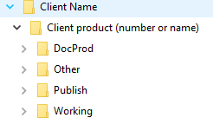

Submission Publishing:

\\10.29.255.6\Stage (RDS file share)
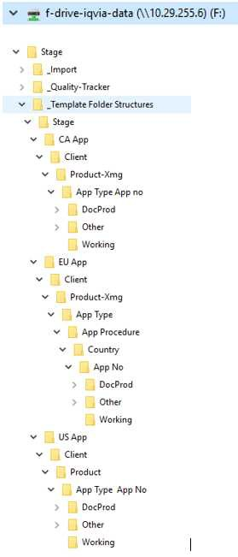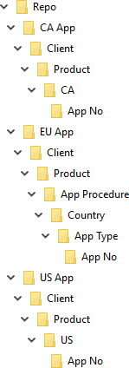
\\10.29.255.6\

File Naming Convention and Version Control examples in the standard directory:
- Original Documents
  - Document file names should be meaningful to the document.
  - A copy of all original documents received is retained in a folder named “Originals” as received until project completion
- Published Documents
  - Document file names should adhere to the file naming standards for the deliverable type and sponsor requirements. Filenames may be changed from the originals.
- Source Documents
  - Source documents (i.e., MS Word) that are converted to PDF will be retained in a separate folder and archived with the project.
- Versioning of Documents
  - A \Date subdirectory in the \DocProd and \Working directories should contain subfolders indicating any official client or author versions received during the editing process.
  - The eCTD Lead or MW should not version any source document released for publishing without requesting the document from the RADDS Publisher to ensure the latest version is used.
- Storing Documents:
  - Documents should be stored according to the folder content, as described above.

Appendix C: Process Flow

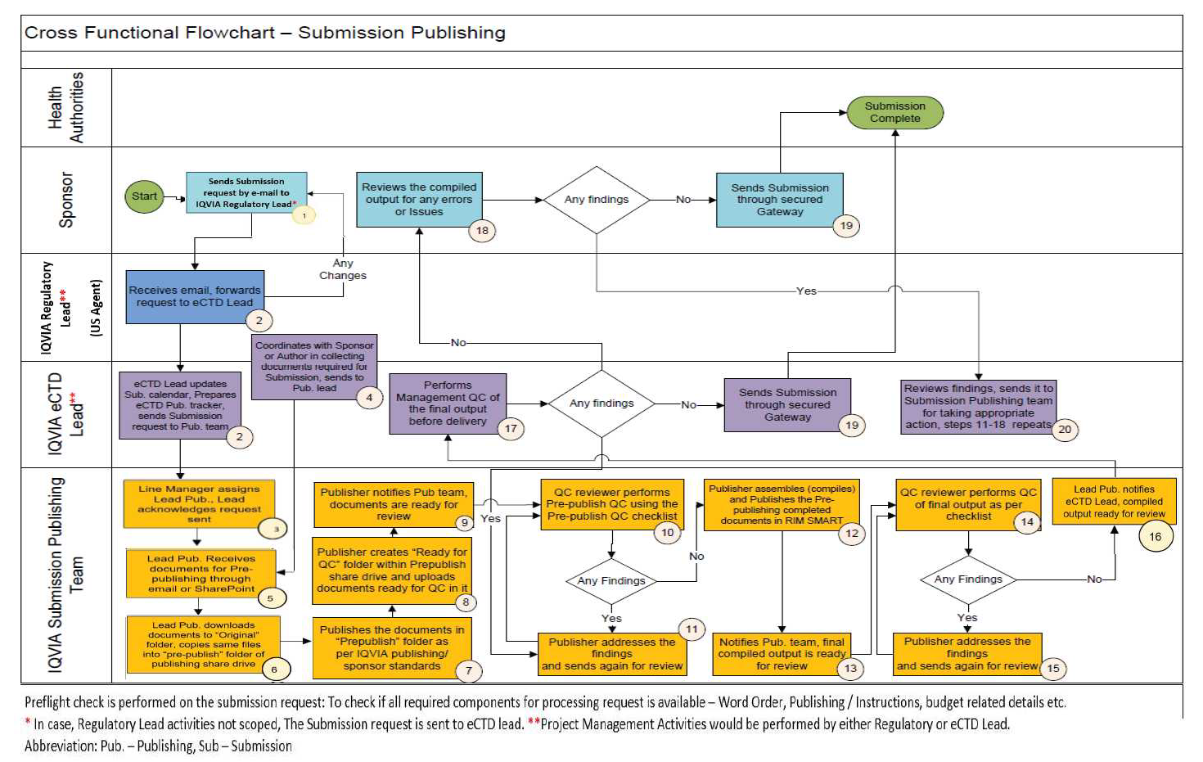

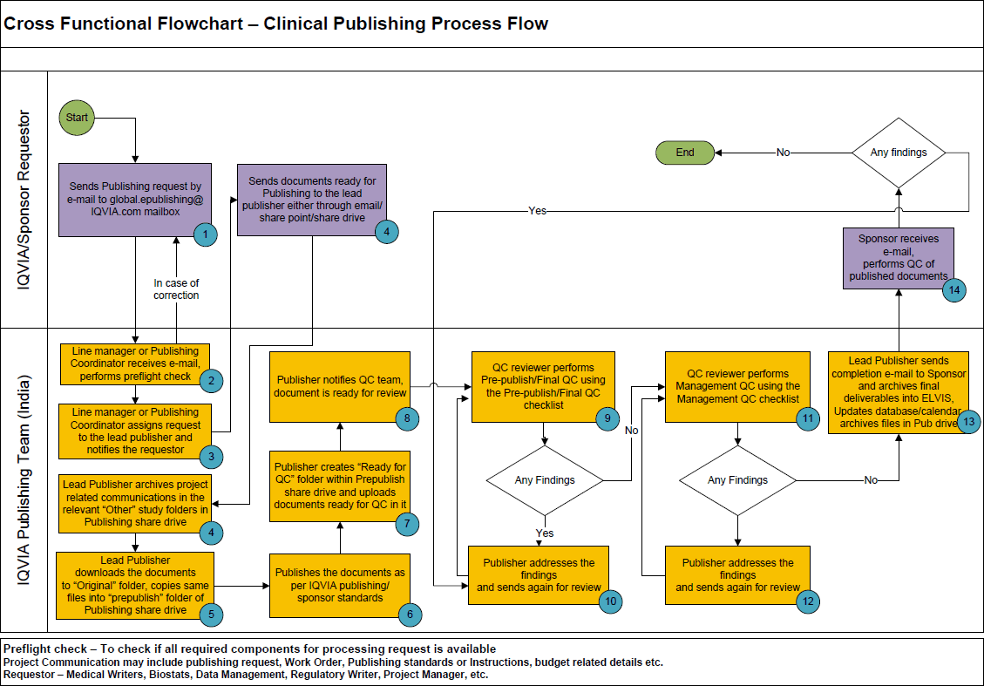

Page 23 of 23
Copyright © 2019, 2020, 2021, 2022 IQVIA. All rights reserved. The contents of this document are confidential and proprietary to IQVIA Holdings Inc. and its subsidiaries

UserName: Schreiber, Cindy (q831321) Title:
Date: Monday, 21 November 2022, 08:37 AM Eastern Daylight Time Meaning: Signing this Document Indicates My Approval
================================================

UserName: Willmott, Corinne (q778849) Title:
Date: Monday, 21 November 2022, 08:40 AM Eastern Daylight Time Meaning: Signing this Document Indicates My Approval
================================================

UserName: Kemp, Jaco (q608126) Title:
Date: Monday, 21 November 2022, 10:20 AM Eastern Daylight Time Meaning: Signing this Document Indicates My Approval
================================================

UserName: Pokharkar, Swapnil (q1019141) Title:
Date: Monday, 21 November 2022, 10:59 AM Eastern Daylight Time Meaning: Signing this Document Indicates My Approval
================================================

UserName: De Pauw, Anja (q610302) Title:
Date: Monday, 21 November 2022, 11:17 AM Eastern Daylight Time Meaning: Signing this Document Indicates My Approval
================================================

UserName: NAJI, Kenza (u1090913) Title:
Date: Monday, 21 November 2022, 01:30 PM Eastern Daylight Time Meaning: Signing this Document Indicates My Approval
================================================

